**Doubling the Income of Village**

**Chapter 1**

* 1. **Aim:**

1. To understand the situation of the village Rayanal.
2. To come up with the solution for the problems facing in the village.
   1. **Rayanal: The Challenging Harmony of the People!**

Rayanal is a village in Dharwad district of Karnataka, India.

According to Census 2011 information the location code or village code of Rayanal village is 602404. Rayanal village is located in Hubli taluka of Dharwad district in Karnataka, India. It is situated 8km away from sub-district headquarter Hubli (tehsildar office) and 25km away from district headquarter Dharwad. As per 2009 stats, Rayanal village is also a gram panchayat.

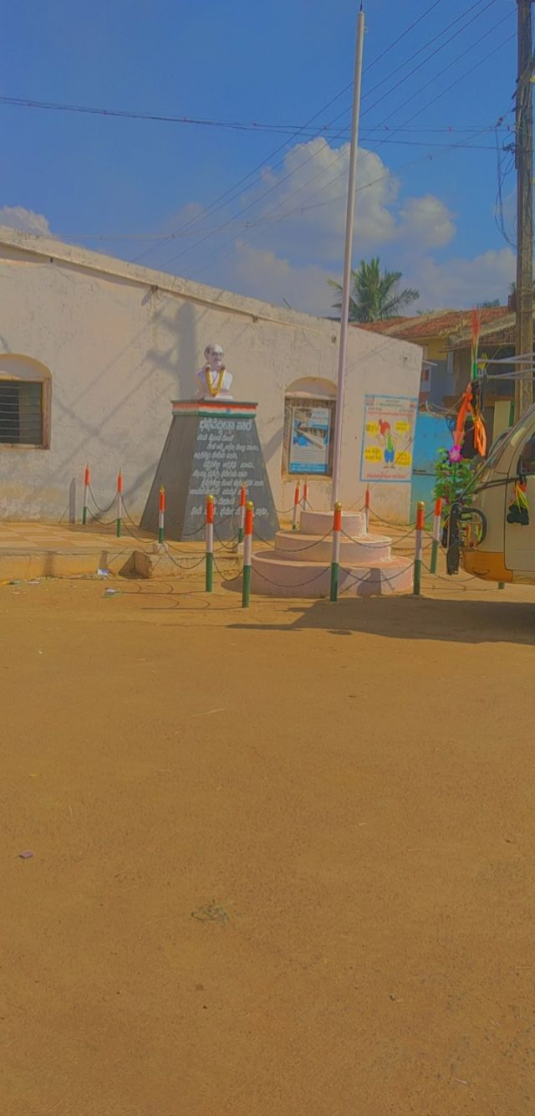As of the 2011 Census of India there were 534 households in Rayanal and a total population of 2,614 consisting of 1,339 males and 1,275 females. There were 305 children ages 0-6. And witnessing Rayanal village after 10 years with a great change is a different and vivid experience for all of our teammates, comprising of 550 households, with increasing number of Population.

**Fig 1.1 Entrance**

**of Rayanal**

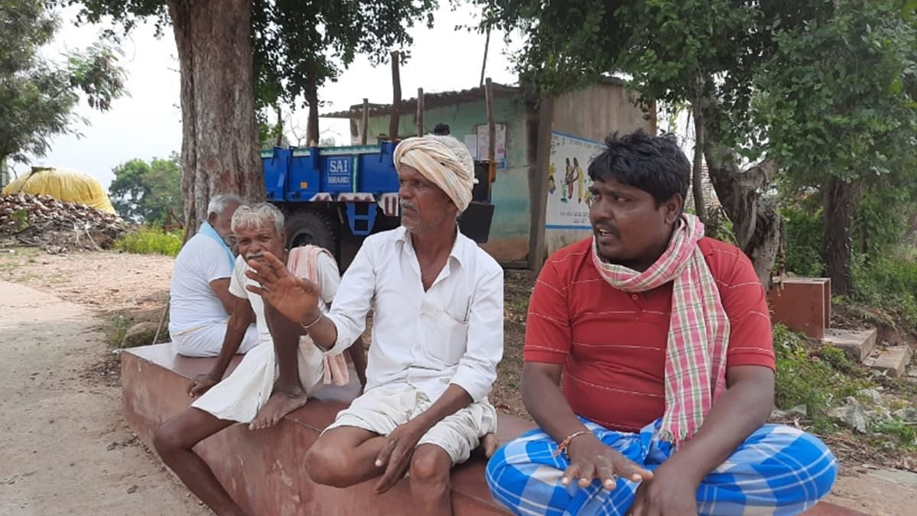

**Fig 1.2 People**

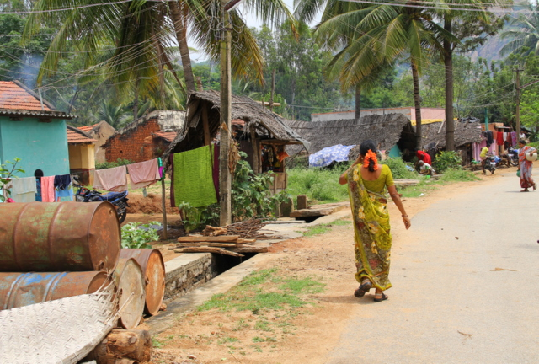

Geogrphical Area:

The total land area of Rayanal is around 547.08 hectares (1351.86 acres). which consists of a total household of around 534. the nearest village to Rayanal is Hubli (8 km)

Karnataka (State)

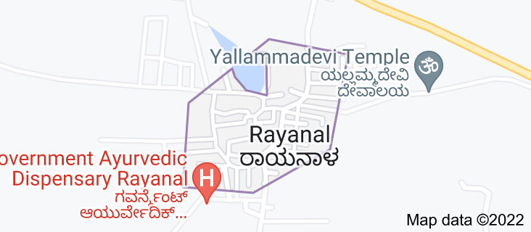↓

Dharwad (District)

↓

Hubli (Taluk)

↓

Rayanal (Village) **Fig 1.3 Map of Rayanal**

Time Zone: UTC+05:30 (IST)

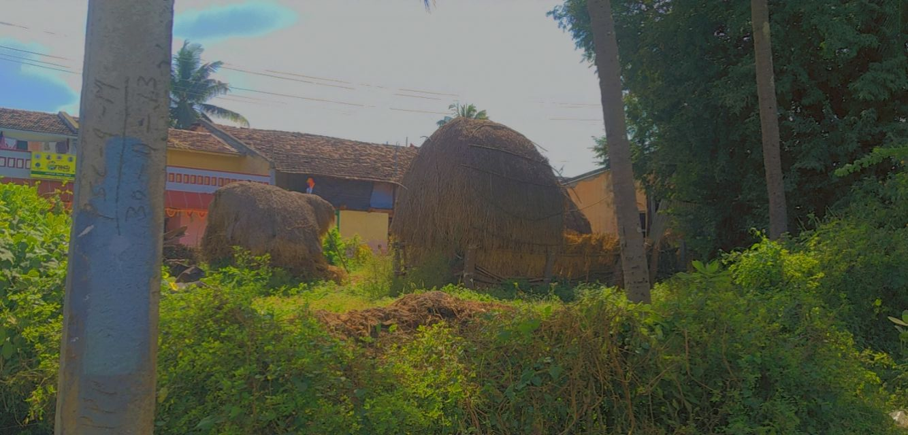Rayanal post office comes under Dharwad division in North Karnataka region, which provides delivery services across the village and near by. Hubli H.O is the head office of Rayanal post office and NA is the nearest sub office. Telephone no of the post office is - 0836-2221612. Houses at the village has made a better version of the old self of the villages by slowly turning into pucca houses.

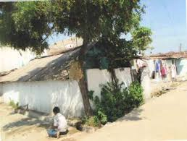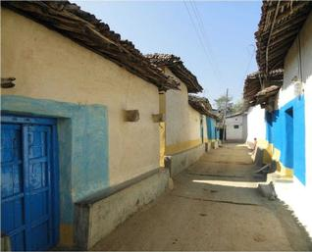**Fig 1.4 Housing**

There is nothing of a very good way of transport. But still the village has the Road transportation. Buses are available for the travel of People from Rayanal to out of the village and vice versa.

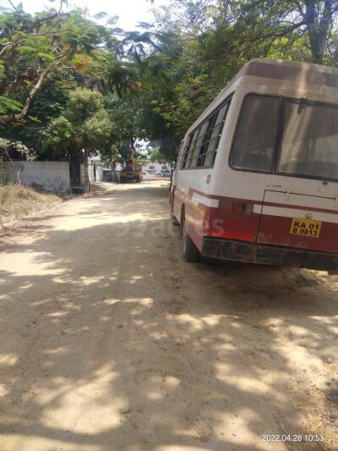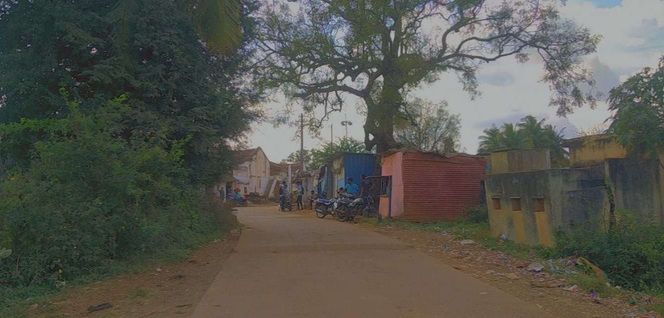 **Fig 1.5 Road ways**

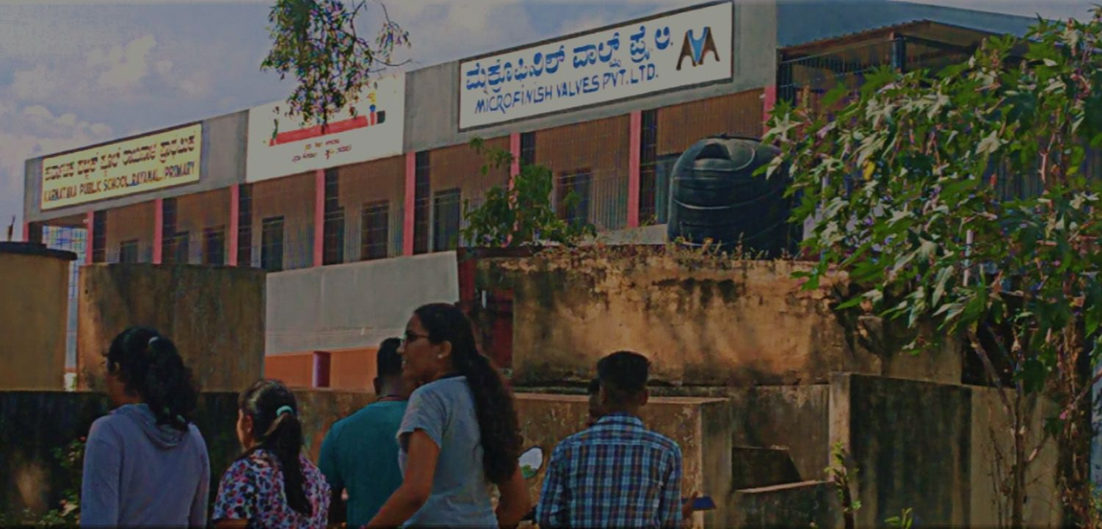Schooling:

Education in rural school is just like full package of joy, social knowledge, leadership skill etc., they are not forced to learn anything,

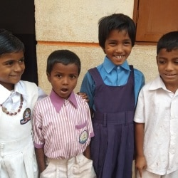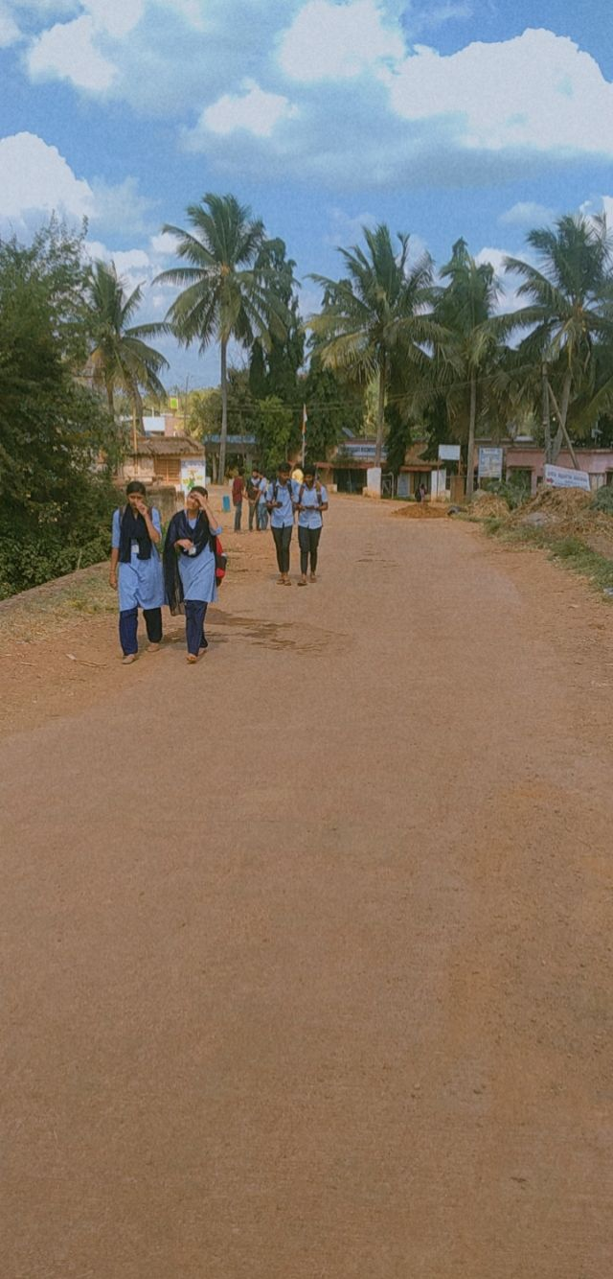

**Fig 1.6 Schools**

Literature Survey:

As the surveying goes on, we came out with a few of the problems that villagers had listed out. Though the village is well developed and have a better implementation of various things   
Yet Rayanal lacked in few things such as:

* Each family could not earn a proper annual income.
* Most of the families were unaware of the schemes provided by the Government.
* We can number out the people, who have knowledge of Computer. Not many have the exposure to the computer skills.
* Though people have lands in their own hands, but they could not produce the crops and are much dependent on the city salaried employment in the Private sector.
* People who are producing the crops are depending on the rainfall for their production due to the less income they are having.

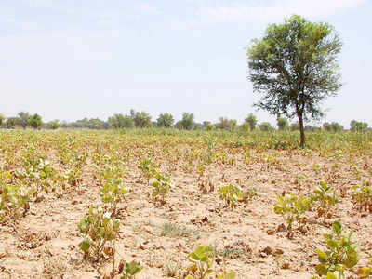

**Fig 1.7 Partial growth of crops**



**Fig 1.8 Job search**

Unemployment and under-employment are the two main problems on the job front that Karnataka is staring at. Both have the potential to create social chaos down the line, tending towards criminal and illegal activities, and the problem is likely to be much larger than we know.

Even small and middle farmers in the irrigated belts of Raichur district have migrated as both Narayanpur and Tungabhadra reservoirs are almost dry. Most people migrate from Hyderabad Karnataka region — particularly from Shahpur, Surpur, Yadgir, Manvi, Lingsugur, and Deodurg taluks — to be absorbed into the construction industry in Bengaluru, Hyderabad and other metros. However, with construction activities on a downswing after demonetisation, these metros are not pulling the rural labourers like they used to.

Last month, unemployment rate for Karnataka was 2.73 %. Though Karnataka unemployment rate fluctuated substantially in recent months, it tended to increase through November 2021 - October 2022 period ending at 2.73 % last month.

As a result, a considerable size of labourers from Hyderabad Karnataka region, who would seasonally migrate to these places, was forced to stay back at their villages finding alternative work.

**Chapter 2**

* 1. **Solving out Intellectually**

****We as a group had come up with few of the solutions that can help out the Rayanal village. As we’ve taken the Case Study of the Rayanal village, we thought of few ideas of introducing the village ‘Starting a Side Business’. Being engaged in various different works like Farming, Poultry, Government service paid works etc., can bring us revenue, but getting involved in the side business gives out a good fortune. Poultry, Eateries, Growing Flowers and delivery services, Food delivery services etc., we’ve come up with one such service, that we ae going to explore in further pages.

**Starting a Side Business: Side Hustle!**

What is Side Business?

A side business can be defined as a business activity that someone does besides their main activities there are many types of side businesses, from product sales to services. This is the aftermath of the ability of side business in realizing people’s dreams of earning extra income.

Benefits of Side Hustle:

Having a side business offers you an opportunity to earn extra money while carrying your full-time job.

A side hustle can offer you the opportunity to explore your passions or pursue your dream job, without sacrificing the steady pay check of a day job. Not only does a side hustle provide an injection of extra cash flow to your bank account, it can also help to boost overall life satisfaction.

Another benefit of side hustle is that the increased financial freedom that a side hustle provides can not only help with getting out of debt, but it can also help with saving for a rainy day, building a nest egg, or taking care of large purchases or maintenance required around the home. It can also provide for a bit of discretionary spending in your monthly budget.

**2.2 Proposal:**

 We are mainly focusing on encouraging the Individual villager’s, traditions such as Handiworks, Traditional foods from their ancestors for the future generation and promoting it further, through side hustle, and later make it notable through latest technologies.

What is tradition or culture?

Dictionary meaning of Tradition or culture is that, the transmission of customs or beliefs from generation to generation, or the fact of being passed on in this way. The ideas, customs, and social behaviour of a particular people or society.

What does Promoting Traditions mean?

Traditional marketing encompasses all of the activities used to create consumer value. Under the practice of marketing, advertising is one major tool used to promote products and services to the public. In addition to its intrinsic value, culture provides important social and economic benefits. With improved learning and health, increased tolerance, and opportunities to come together with others, culture enhances our quality of life and increases overall well-being for both individuals and communities.

Why we need to Promote Culture?

Participating in culture can benefit individuals in many different ways, some of which are:

* They are a source of delight and wonder, and can provide emotionally and intellectually moving experiences, whether pleasurable or unsettling, that encourage celebration or contemplation.
* Culture is also a means of expressing creativity, forging an individual identity, and enhancing or preserving a community’s sense of place.

#### Improved learning and valuable skills for the future, culture helps develop thinking skills, builds self-esteem, and improves resilience, all of which enhance education outcomes.

#### Better health and well-being, participation in culture contributes to healthy populations in several ways. Creativity and cultural engagement have been shown to improve both mental and physical health.

### Economic benefits of culture, knowledge-based economies favour ideas to stimulate innovation, and they develop specialized services and highly customized products to create value.

Role of Culture in Business:

Successful businesses have learned the importance of culture in a company and how it can increase employee morale, encourage equitable workplaces, and boost profits.

Cultural adaptation in business encompasses organizational culture as well as national cultures and traditions. It helps the organizations to have a better understanding of how local businesses and the workforce function.

 It's what makes your business unique and is the sum of its values, traditions, beliefs, interactions, behaviours, and attitudes. Positive workplace culture attracts talent, drives engagement, impacts happiness and satisfaction, and affects performance.

**2.3 Strategies**

Different kind of traditions can be:

* Handiworks
* Ancestorial traditional Recipes
* Language
* Dances etc.

**Handiworks:**

A handicraft, sometimes more precisely expressed as artisanal handicraft**,** is any of a wide variety of types of work where useful and decorative objects are made completely by one’s hand or by using only simple, non-automated related tools like [scissors](https://en.wikipedia.org/wiki/Scissors), carving implements, or [hooks](https://en.wikipedia.org/wiki/Hook). It is a traditional main sector of [craft](https://en.wikipedia.org/wiki/Craft) making and applies to a wide range of creative and [design](https://en.wikipedia.org/wiki/Design) activities that are related to making things with one's hands and skill, including work with [textiles](https://en.wikipedia.org/wiki/Textile), mouldable and rigid materials, paper, plant fibres, clay etc. 

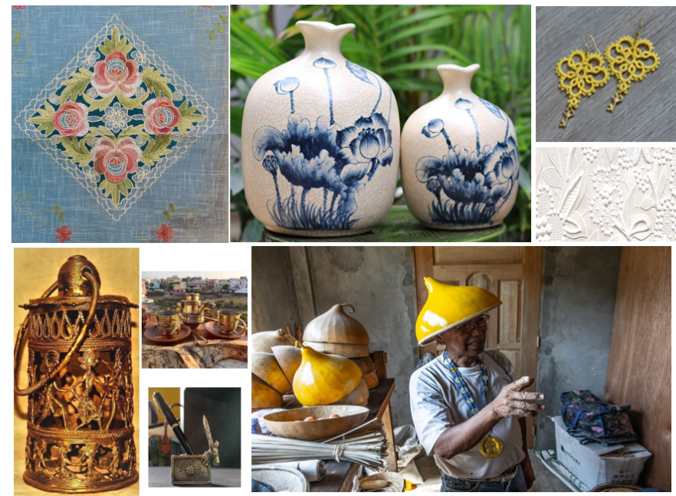**Fig 2.1 Handiworks**

In recent times or way back, we can see there are many handiworks that evolved over years such as [Dhokra](https://en.wikipedia.org/wiki/Dhokra" \o "), [Wood carving](https://en.wikipedia.org/wiki/Wood_carving), [Iris folding](https://en.wikipedia.org/wiki/Iris_folding), [Bead work](https://en.wikipedia.org/wiki/Bead_work), [Tatting](https://en.wikipedia.org/wiki/Tatting), [Chip carving](https://en.wikipedia.org/wiki/Chip_carving), [Egg decorating](https://en.wikipedia.org/wiki/Egg_decorating), Making conical hats, M[illinery](https://en.wikipedia.org/wiki/Hat_making), [Lapidary](https://en.wikipedia.org/wiki/Lapidary),  [Bat-Trang-Ceramic](https://en.wikipedia.org/wiki/Bat_Trang_Porcelain), A hand made sofa set made from fibers extracted from bamboo, Handcrafted shoes from bamboo etc.

**Traditional Recipes:**

Traditional Indian foods have been prepared for many years and preparation varies across the country. Traditional wisdom about processing of food, its preservation techniques, and their therapeutic effects have been established for many generations in India. Food systems can deliver numerous biological functions through dietary components in the human body. Indian traditional foods are also recognized as functional foods because of the presence of functional components such as body-healing chemicals, antioxidants, dietary fibres, and [probiotics](https://www.sciencedirect.com/topics/nursing-and-health-professions/probiotic-agent). These functional molecules help in weight management, and [blood sugar level](https://www.sciencedirect.com/topics/nursing-and-health-professions/glucose-blood-level) balance and support immunity of the body. The functional properties of foods are further enhanced by processing techniques such as sprouting, malting, and fermentation.

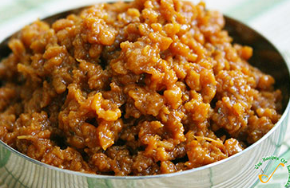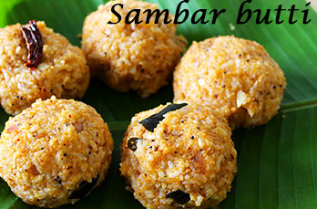Aryans are a heterogeneous group of people who lived in different parts of ancient India. They migrated from Indo–Iranian borderlands with their cultures and customs. The early stage of their settlement with their religious tradition in India is known as the Vedic period. Later the ruling classes in their regions were drawn to the Vedic religion.

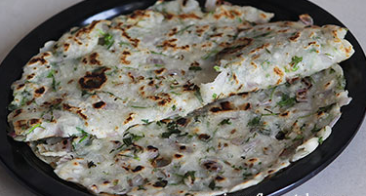

**Fig 2.2 Recipes**

Aryans believed that food was not simply meant for body nourishment, but was the basic part of a cosmic moral cycle. Barley became the Aryans' initial [staple food](https://www.sciencedirect.com/topics/food-science/staple-food), and is also mentioned in the Rigveda. Later texts mention wheat, lentils, millets, and sugarcane. The most popular lentils used were red lentils, green lentils, and black lentils. Apupa is a form of cake prepared by frying barley. Kichidimade from rice together with lentils or dal is highly nutritious. Aryans knew about rice cultivation; parched rice and cereals were a common method of processing during their period. Lentils and rice were the combinations of complementary nutritional elements consumed by Aryans. The literature of Buddhists and Jains reveal the extensive use of rice and its gruel. During the Jain period, cloth was soaked in milk and dried to yield a reconstituted product called kholas.

**Languages:**

Karnataka is home to around 150 languages belonging to different language families. Though Kannada is the major language of the state, Urdu, Konkani, Kodava and Tulu are also widely spoken. Karnataka is the second major state in terms of speaker strength for languages like Tamil, Marathi, Telugu, Malayalam and Konkani. Some of the major languages of India like Marathi and Dakhani Urdu are said to have evolved in this region. Languages like Tamil, Marathi, Telugu, Bangla, etc also have their different dialects spoken in Karnataka. Apart from all these major languages, Karnataka also encompasses several minor languages like Sanketi, Aruvumu, Vaddari etc. Many tribal languages like Korava, Koraga, Badaga, Irula etc, are spoken within the state. All these languages and dialects being in close proximity with each other has led to major linguistic contact situations.

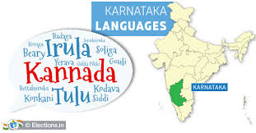

**Fig 2.3 Communication**

Kannada being a major language has naturally influenced the other minor and tribal languages and dialects. It is also noticed that Kannada shows instances of influence from many other languages and dialects. Also, 72 tribal languages are spoken and the study has recorded 42 of them. The linguistic census also shows Karnataka has 50 tribal languages, along with 22 Scheduled Tribes.

**Songs & Dance:**

Karnataka’s famous dances involve many different folk dances along with some of India’s leading classic dances. So far there were so many dances which are presently known to the public. Similarly, one day we will explore and find new dances which are treasured within the families of the villagers. Just like the **Dollu Kunitha Dance, Nagamandala Dance etc.**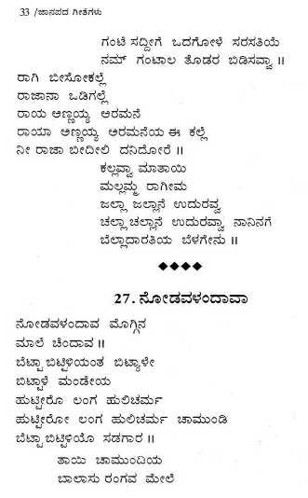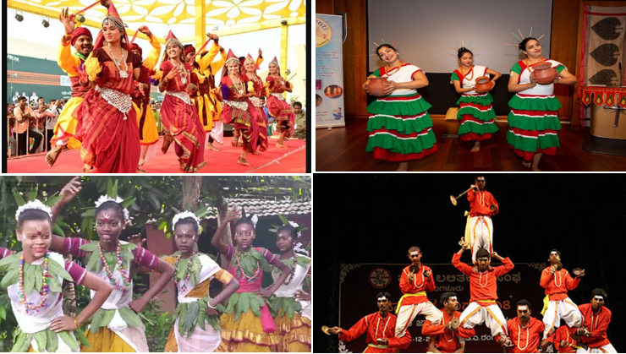

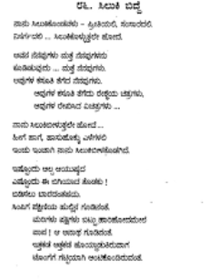

**Fig 2.4 Folk arts**

Some of the popular Ballads are: Gunasagari, sarajappa nayakana kathe, madakari nayaka, kiththuru chennamma, sangoli rayana, balanagamma, Malaya madeswra kavya, manteswami kavya, yallammana kavya, mailaralingana kavya

**Chapter 3**

### **3.1 Cost of a Side Hustle:**

**Fig 3.1 Cost factors**

The amount of investment that a business requires depends on the type of business. And how much the small business owner can put in the business. Mostly all small business owners require some funds when they are starting with their own business for which a loan is required.

No matter how smaller or bigger the business is, we need the minimum amount of the money as an investment for the profits that we’ll receive for the better tomorrow.

**3.2 Key Challenges & Solutions**

* Failure to plan

**CHALLENGE:** With the excitement of a new business idea, it can be tempting to launch without much [forward-thinking](https://www.startuploans.co.uk/business-advice/setting-business-aims-objectives/) .

Yet a lack of planning can mean your business [runs out of cash](https://www.startuploans.co.uk/business-advice/3-cashflow-essentials/)  or isn’t prepared for vital activities such as marketing or [dealing with suppliers](https://www.startuploans.co.uk/business-advice/choosing-right-supplier-business/) .

**ACTION:**Create a [detailed business plan](https://www.startuploans.co.uk/business-advice/how-to-write-a-business-plan/) that covers areas such as [marketing](https://www.startuploans.co.uk/business-advice/marketing-on-a-shoestring/) [staffing](https://www.startuploans.co.uk/business-advice/how-to-hire-staff-for-your-business/), [finance](https://www.startuploans.co.uk/business-advice/9-tips-to-start-a-business-on-a-shoestring/) and [sales](https://www.startuploans.co.uk/business-advice/8-essential-sales-techniques-to-unlock-business-growth/).

Regularly review and update your plan as [the business develops](https://www.startuploans.co.uk/business-advice/reassess-your-business/).

### Financial management

**CHALLENGE:** Poor financial planning is one of the biggest reasons start-ups fail.

If your [costs are greater than the revenue](https://www.startuploans.co.uk/business-advice/how-to-reduce-costs-grow-profits/) coming in, your business won’t succeed.

**ACTION:** You need to understand all the costs your start-up will incur and make sure that your products or services are [priced appropriately](https://www.startuploans.co.uk/business-advice/how-to-price-your-products-and-services/) to make a profit.

### Lack of demand

**CHALLENGE:** Understanding the market need for your product or service is a crucial aspect of your business plan.

Without enough [people willing to buy your product or service](https://www.startuploans.co.uk/business-advice/how-to-win-customers/), your start-up won’t succeed, no matter how great your idea.

**ACTION:**Spend time conducting [market research](https://www.startuploans.co.uk/business-advice/what-is-market-research/) to collect information about potential customers.

### Ineffective marketing

**CHALLENGE:** It can be easy to get caught up in the latest marketing trends and spend lots of money on marketing techniques that end up costing you more than the sales they generate.

**ACTION:** Marketing should be effective.

### Knowledge and skills gaps

**CHALLENGE:** As a first-time entrepreneur, it’s unlikely you’ll know everything about running a business.

A lack of knowledge can lead to avoidable mistakes that could cost your business money.

You’ll also need to overcome enormous demands on your time and energy setting up a business.

**ACTION:** Absorb as much information you can, particularly about the [industry that you’re entering in new window](https://www.startuploans.co.uk/business-advice/how-to-spot-a-gap-in-the-market-and-act-quickly/), the [customers you’re targeting in new window](https://www.startuploans.co.uk/business-advice/the-secret-to-effective-selling/) and the [competitors you face in new window](https://www.startuploans.co.uk/business-advice/competitor-research-guide-for-start-ups/).

### Time management and productivity

**CHALLENGE:** Managing your time effectively is crucial when launching a start-up.

New business owners have to wear so many hats that it can be easy to get distracted and focus on the wrong areas. Getting And Retaining Customers

**ACTION:** Planning is vital as it will keep you on track and focused on your goals.



**3.2 Advancing the Approach**

* Marketing the ideas can be one of the ways to cultivate the presently formed idea or business, in a way it can create a new ways and roads for the future development of the budding business.
* Socializing the trade, through the present technologies can help in productivity and management of the Business.



**Fig 3.2 Socializing**

### Start a YouTube channel.

### Can do the vlogs, for this technology is a very hype in recent times of the era.

### Learn online courses and teach it to others.

**3.4 Why we choose this approach?**

There are many reasons for us to choose this as an approach. Out of which were the following

* We wanted to let villagers know that they can share their culture out with the world and can promote it to the future, when it is in the line of extinct.
* They can earn the yearly earnings through this way as well and not just by the skilled wage works or just by farming. As we all know the troubles a farmer faces due to the rain or financial unstableness. A farmer can be profited sometimes or can even face a an utterly failure. We wanted to that they can even participate in the running world and can depend on the other side too.
* They can even run in this world, even after being grey. They still have a long way to go for they can learn the recent times technologies, for there is no age to learn, all the way until the last moment a person can learn.
* We may think how can Language and a folk Songs and Dances can bring us revenue! But a Language helps with composition of a poem which helps indirectly.
* Now, coming to folk songs and dances, they are a great way to promote your side business. They can attract customers with their catchy melodies, themes and messages. You can also use them to educate your customers about your products or services, share your stories or express your feelings. Folk songs can also help you build your brand identity and credibility.

REFERNCES

* <https://en.wikipedia.org/wiki/Rayanal>
* <https://lio.io/blog/business-ideas-in-karnataka/#15-flowers-delivery-service>
* <https://www.hashmicro.com/blog/best-ideas-side-business/>
* <https://www.wonolo.com/blog/what-is-a-side-hustle/>
* <https://national-policies.eacea.ec.europa.eu/youthwiki/chapters/france/84-promoting-culture-and-cultural-participation>
* <https://www.usemultiplier.com/blog/culture-in-international-business>
* <https://en.wikipedia.org/wiki/Handicraft>
* <https://www.sciencedirect.com/science/article/pii/S2352618115000438>
* <https://vegrecipesofkarnataka.com/north-karnataka-recipes.php>
* <https://www.dailypioneer.com/2013/india/10-tribal-languages-on-the-verge-of-extinction-in-karnataka-study.html>
* <https://www.tusktravel.com/blog/traditional-folk-dances-of-karnataka/>
* <https://www.incfile.com/blog/how-much-does-it-cost-to-start-a-side-hustle>
* <https://www.startuploans.co.uk/business-advice/10-biggest-startup-challenges/>
* <https://www.wordstream.com/blog/ws/2020/07/29/how-to-promote-a-product>
* https://www.shopify.com/in/blog/side-hustle

**Team Members**

|  |  |
| --- | --- |
| USN | NAME |
| 2KE21CS401 | Bhagya Kammar |
| 2KE21CS400 | Ashwini Maruti Rawal |
| 2KE21CS403 | Kanchan S Tripathi |
| 2KE20CS116 | Ch. Sheeba |
| 2KE20CS117 | Bommaji Leuitisha |
| 2KE20CS014 | Mohammad Zulnoon Raisulhasan |
| 2KE20CS004 | Akash K Halemani |
| 2KE21CS405 | Nagaraj Sadanand Raykar |
| 2KE20CS112 | Sadiqahmed M Nadaf |
| 2KE21CS404 | Munthar Misrikoti |